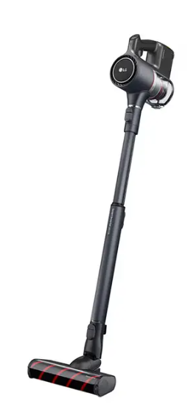

LG Vacuum Cleaner
Rs.35,184
An LG vacuum cleaner is a high-performance cleaning appliance designed for powerful dust removal, advanced filtration, and multi-surface cleaning. LG offers different types such as bagless, cordless stick, robot, and drum vacuum cleaners for various home needs.

Specifications
- Power: 1800W – 2600W
- Water Tank Capacity: ~150 – 300 ml
- Weight: ~4–8 kg (varies by type)
- Noise Level: ~60–82 dB

Key Features
- High Suction Power
- HEPA Filtration System
- Multiple Attachments
- Cordless / Corded Options

